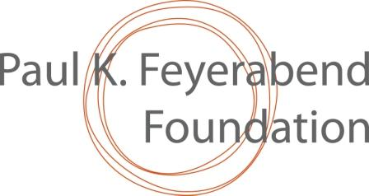
Form to propose a candidate for the
2021 Paul K. Feyerabend Award
(to be filled by the Nominator)

Name and e mail address of the Nominator:

…………………

Name of the person, community or organization candidate to receive the Award (please add their postal address, phone, web site and e-mail, as applicable):

……………………….

Brief description of the accomplishments that justify this candidature, in particular about how the work of the candidate strengthens or generates intra or inter-community solidarity:

………………………..

Description of the work context of the candidate, including a mention of eventual circumstances that may have rendered the accomplishments harder and worthier of recognition:

……………………………

All other pertinent information regarding the candidate:

…………………………….

If the candidate will receive the PKF Award, will this be of inspiration and motivation to others? If yes, to whom in particular? Why and how?

……………………………

Possible bibliographic references and audiovisual documentation (please send only electronic versions and only list other possible types of documentation, such as books and films, and where could they be obtained):

…………………………….

Many thanks! Please submit this filled form to secretariat@pkfeyerabend.org with copies to josiane.olff-nathan@orange.fr and to gbffilter@gmail.com

