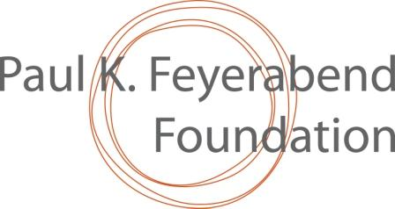 Form to request a grant in 2024

PART A – to be filled by the entity requesting the grant and submitted to the relevant Nominator – (Please use Calibri 11 pt or Times New Roman 11 pt)

Short title of proposed initiative, clearly expressing its main focus: ...................................

Entity responsible for the initiative: (names, postal address, e-mail, telephone number for WhatsApp, bank coordinates + relevant experience) and key actors in the initiative – (max. 1 page): ……………

Historical and geographic context, including a description of the concerned community (or communities) and, as applicable, a simple map of the relevant area – (max. 1 page): ………………………….

General and specific objectives of the initiative, clearly explaining how those relate to intra and inter-community solidarity - (max. half a page): ………………………

Activities and timing (max. 2 pages). This is the most important section of your proposal: how do you intend to pursue your objectives? Please describe the activities you wish to be supported by the Foundation in a chronogram where activities are listed against time and desired results, as in the table below:

Activity | First year |  |  |  | Second year (if applicable) |  |  |  | Expected Result
Act 1
Act 2
Act 3
Etc.

Budget over time (clearly state whether 1 or 2 years), mentioning the unit of currency, its exchange value in Swiss Francs (CHF), the local contributions, and the desired schedule of disbursements. Kindly notice that the max. amount for two years is CHF 10,000. Initiatives that request lesser amounts will receive special attention - (max 1 page): ……….

Usually there will be 2 disbursements based on achieved indicators of results. Please clearly state which indicators of community solidarity you will communicate to assess the results before the second disbursement: ……

Have you obtained or are you seeking other sources of support than the PKF Foundation? If yes, describe and explain: …………………………

If you will receive the PKF support, please note specifically when, where and how you will publicly acknowledge it: …………………………

Possible bibliographic references and audio-visual documentation. Please send only electronic versions and, if relevant, list other documents, such as printed books and films, and where they could be obtained. A few electronic pictures of relevant people & issues will be appreciated.

PART B – to be filled by the Nominator and submitted together with part A as noted at the end of this form

Name and e-mail address of the Nominator: …………………..

Recommendation and comments by the Nominator (from zero to five points according to each criterion— 5 being the highest possible score):

Question/ criterion | points | comments
The PKF Foundation exists to foster: “...social justice, human rights, bio-cultural diversity and the empowerment and well-being of human communities via community solidarity and mutual aid, as well as via collective reflexion, organisation and action.” Will the initiative advance these aims?

Is the initiative exemplary? Can it be inspiring to others? To whom, in particular?

Does the initiative clearly strengthen or generate a solidarity engagement within or among the concerned communities?

[Please mention the crucial indicator that, in your view, will allow to assess whether the initiative has achieved that]

Are the results of the initiative likely to be sustainable and possibly replicable?

Is the initiative innovative?

Can the initiative be successfully implemented in the given context? Please consider whether the underlying assumptions are credible, the entity responsible for the initiative possesses the appropriate capacities, etc.

General comments:

Many thanks! Please submit your filled forms to: secretariat@pkfeyerabend.org with copies to josiane.olff-nathan@orange.fr and gbf@pkfeyerabend.org

